Accessing E-books & Audio books from our school library:
From our school home page: https://www.emsisd.com/waysidems

- Click on departments tab

- Click on library

- Then, click on the blue and orange “Click here for Library Search” image

- This will open the Destiny Discover page; Click on “Log in” at the upper right hand portion of the screen

- Students will log in using their 6-digit ID number for both username AND password

- Once logged in, scroll down to either audiobooks or ebooks, then at the upper right of each section, click on “see all”
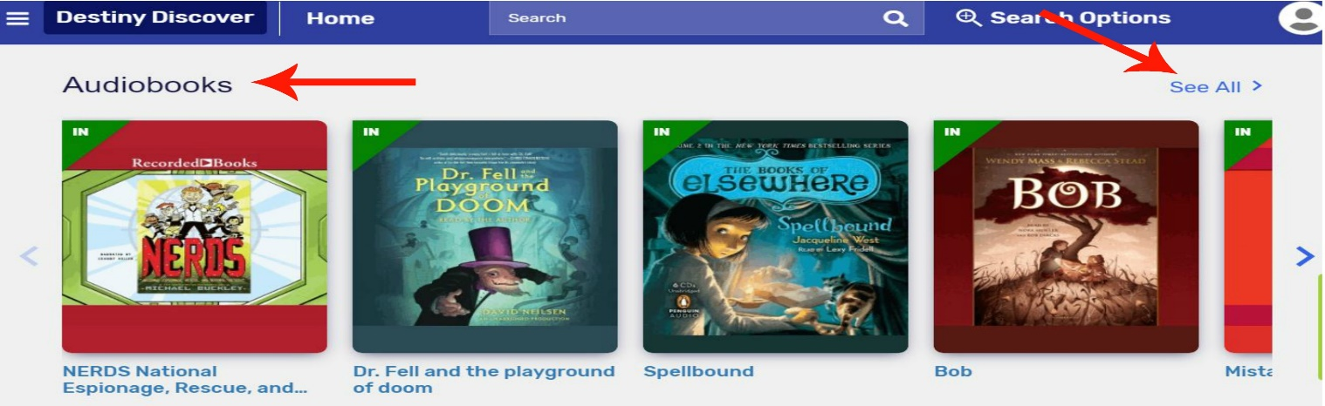

- Students can choose to “play (audio book),” “open (ebook),” or “checkout (audio or ebook)” a selection
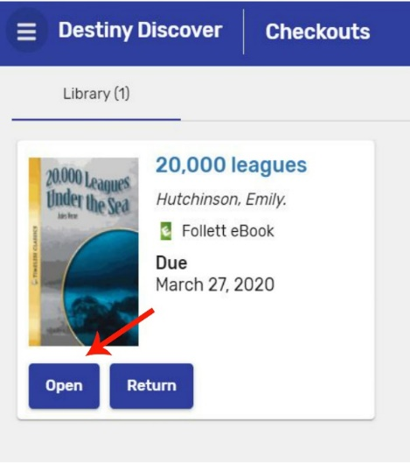

- Checked out selections will be saved to student checkouts, students may access these by going to the “hamburger” icon in the upper left portion of the screen.

- Then, click on “checkouts” to play or read checked out selections.

- Even though the books will automatically be returned on the due date, please return the book when finished so other students have the opportunity to check it out.
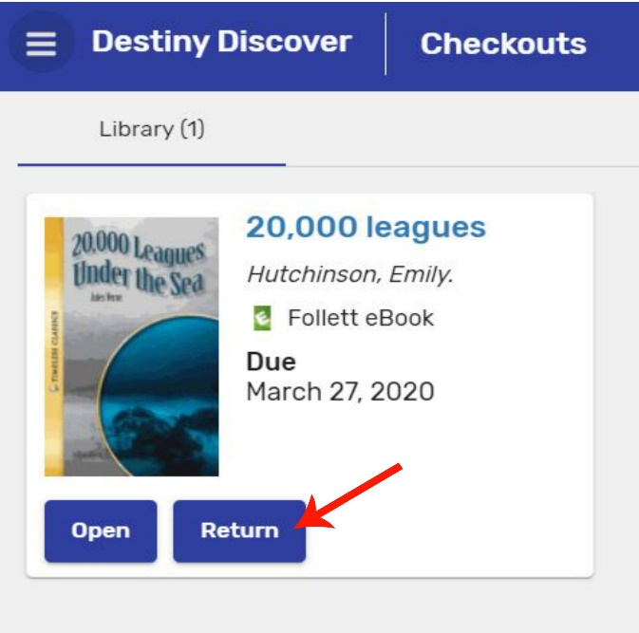

- If you have trouble logging in, please contact Mrs. Ivey at divey@ems-isd.net to have your log in reset.

